Change Request to a Plan of Study
Once a degree-seeking graduate student submits and receives approval on their electronic plan of study, sections of the plan of study may be updated as needed through an electronic change to the plan of study (CPOS) process. CPOSs are not subject to the Plan of Study Deadline, but must be submitted and approved before the end of the session of expected graduation.
There can be only one active CPOS per plan of study at a time.

Student Instructions

Login to myPurdue using your Purdue BoilerKey passcode. Under the “Academics” tab, select the “Graduate School Plan of Study” link in the “Graduate Students” box.
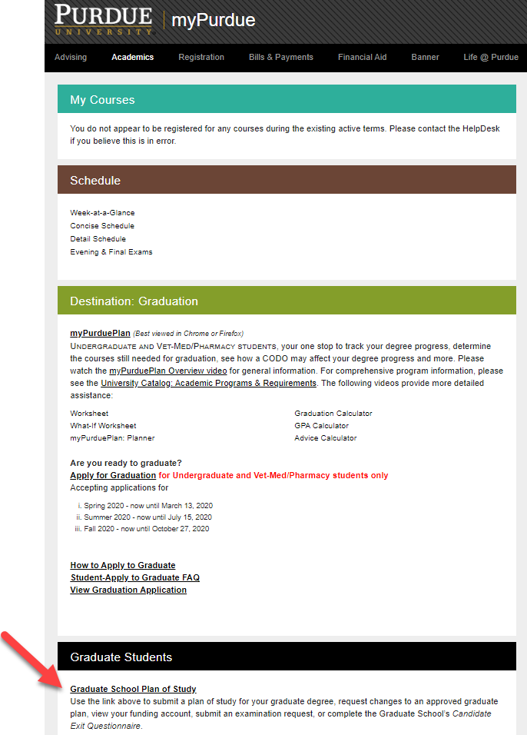

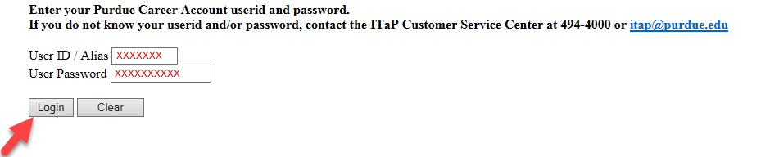
Login to the student portal using your Purdue Career Account credentials.

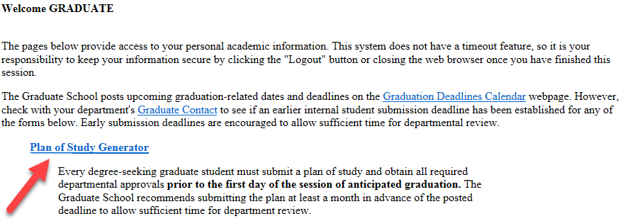
Click the “Plan of Study Generator” link.

Click “Create Change Request.”

Notes on Creating a Change Request

You can only have one active CPOS in the system. For CPOSs in “Outstanding” status, please wait for the request to be approved before initiating a new request. If you have a CPOS in “Saved” or “Draft” status, edit that request rather than initiate a new one. To edit an existing request, select the blue “Edit” link within the Plan of Study Generator to open the main editing page displayed in Step 5:

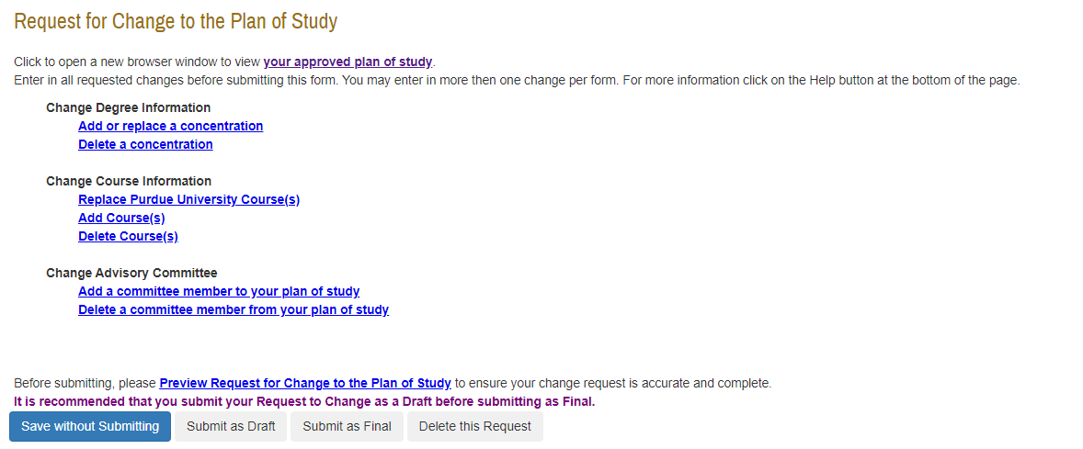
This is the main landing page for the CPOS. Click the appropriate blue link for the type of change you are requesting. Multiple entries can be included on the same change request.

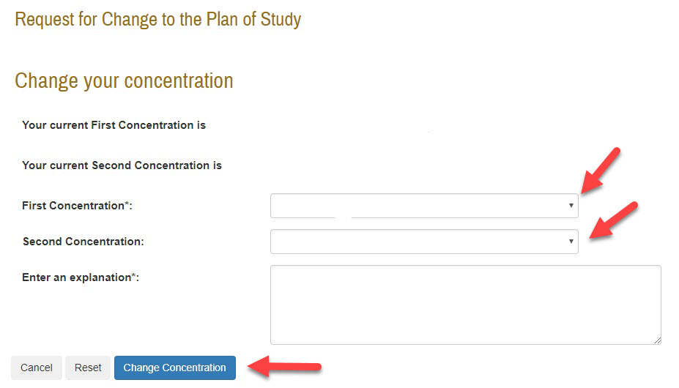
5.1 Add or replace a concentration. Use the drop-down menus to add concentration(s), and enter an explanation in the text box. When completed, click “Change Concentration”. If there are no concentration(s) approved for your major/degree, the drop-down menu will be blank.

Delete a concentration. To delete a concentration, click the box to the left of your current concentration(s). Enter an explanation in the box, click the “Delete Concentration” button, and select “Process and Continue.”
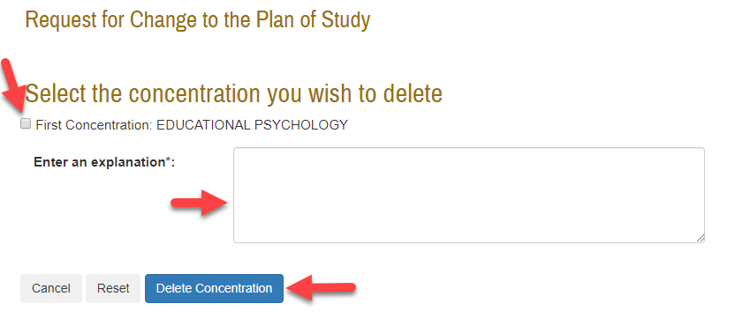

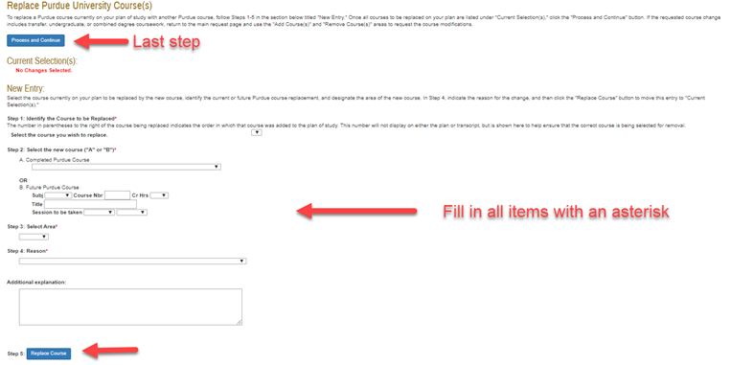
5.3 Replace Purdue University course(s). Fill out the required information under “New Entry” to replace a Purdue course currently on your plan of study with another Purdue course. Click the “Replace Course” button at the bottom of the page once you have filled out all of the required information. Once your request is complete, click the “Process and Continue” button near the top of the page.
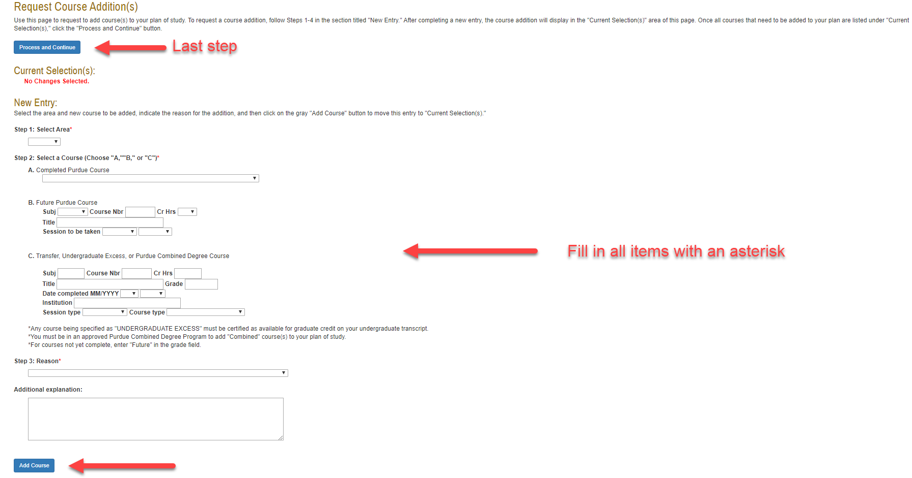
5.4 Add course(s). To add a course to your plan of study, fill out the information below “New Entry” and then click on “Add Course”. Once all of the courses have been added, click the “Process and Continue” button near the top of the page.

5.5 Delete course(s). If you want to delete a course from your plan of study, fill out the information below “New Entry”, and click on the “Delete Course” button at the bottom of the page. Once you have entered all the courses you would like to delete, select the “Process and Continue” button near the top of the page.
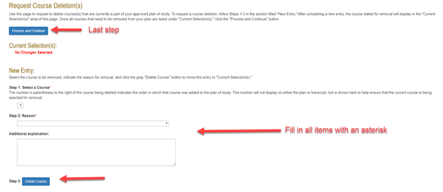
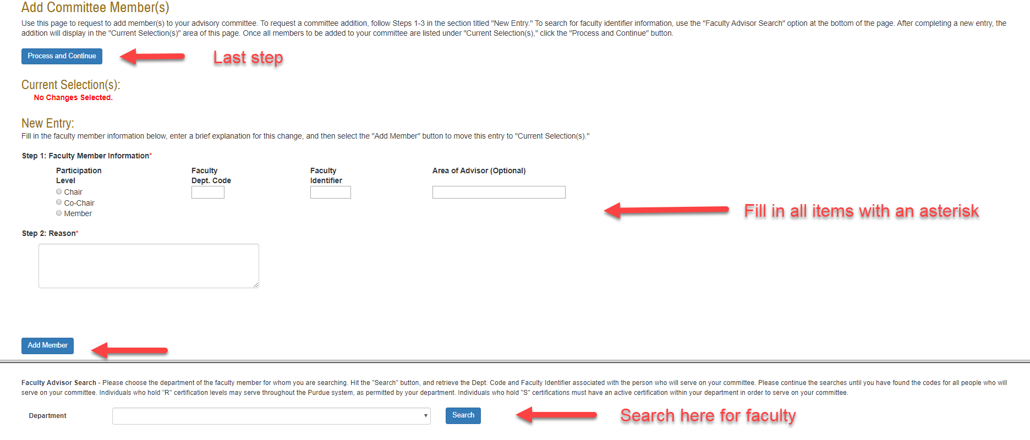
5.6 Add a committee member to your plan of study. To add a committee member, go to the bottom of the page under “Faculty Advisor Search,” choose the Department from the drop-down menu, and then click “Search”. Find the Faculty Dept. Code and Faculty Identifier. Enter this information under “New Entry”. Select the appropriate Participation Level radio button, and fill in the explanation for this addition in the “Reason” box. Click the “Add Member” button when complete.

Note: Refer to Appendix M in the University Catalog for classifications of faculty in terms of which roles they are allowed to serve on a student’s committee.
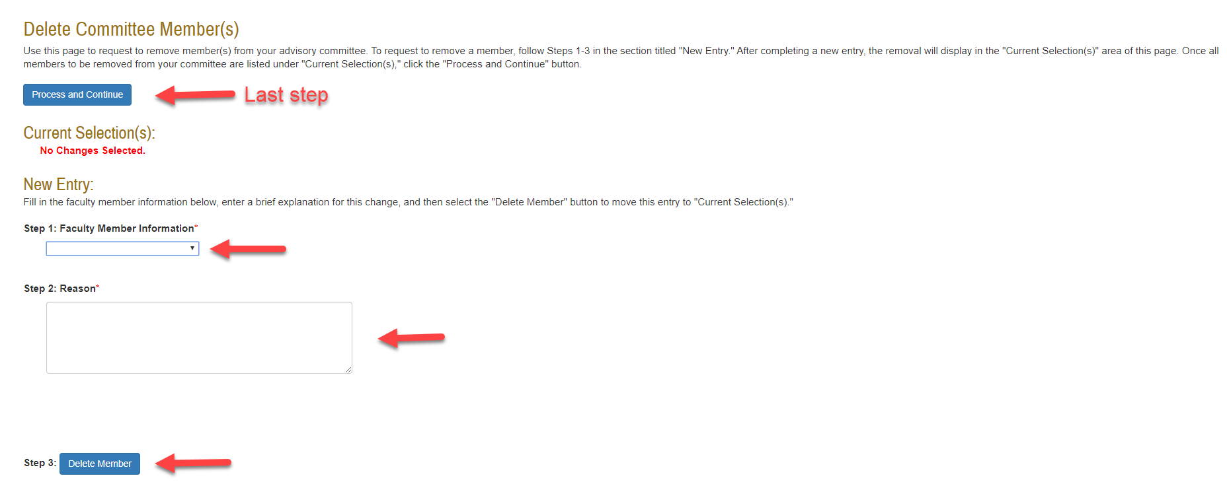
5.7 Delete a committee member from your plan of study. To delete a committee member, use the drop-down menu for “Faculty Member Information” to select the person to delete. Fill out the “Reason” box, and click the “Delete Member” button. Click the “Process and Continue” button near the top of the page when done.

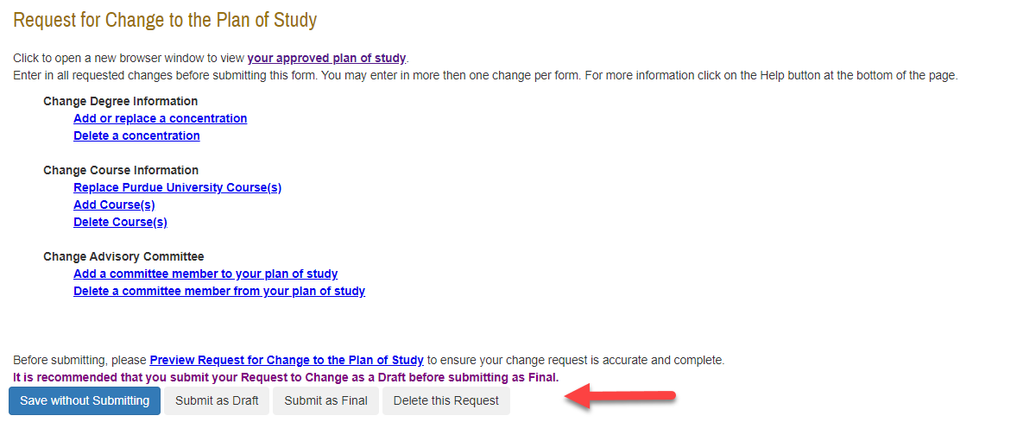
6. When all change(s) have been included on the request, use the grey buttons on the bottom of the CPOS landing page to save, delete, or submit the form.

6.1 Save without Submitting. Click “Save without Submitting” to preserve the information entered for editing at a future time. Change Requests in “Saved” status may be re-accessed by either the student or plan of study coordinator (see notes from Step 4).

6.2 Submit as Draft. Click the “Submit as Draft” button if you would like your advisory committee to see this change request while you still have direct access to make changes.

6.3 Submit as Final. If all key components have been entered into the change request, click “Submit as Final” to submit the request for approval.

6.4 Delete this Request. Selecting “Delete this Request” will remove this request from the system. Deleted requests cannot be re-accessed.

Glossary of Errors
The table below includes a list of error messages you may encounter as you are building the change request, what action produced the error, and suggestions for addressing the issue.

Error Message | Action taken that may have caused the error message | Action to fix Error Message
“You may have only one change request form in "Outstanding" status at any time. Check the signature status of your previously submitted change form by clicking on "Display Submitted Form". The current outstanding form should either be approved or rejected before another change request form may be submitted.” | Clicking “Create Change Request” | For CPOSs in “Outstanding” status, please wait for the request to be approved before initiating a new request. If you have a CPOS in “Saved” or “Draft” status, edit that request rather than initiate a new one.
“One or more required fields are not entered properly. Required fields are marked with an asterisk (*).” | - Duplicate entries  - Adding an entry to the CPOS with missing information (e.g. explanation, course level, etc.) | Check for duplicate listings that need to be corrected, and make sure all fields marked with an asterisk have been filled out.
“No changes selected.” | Replacing Purdue University course(s) | Fill out the required information.
“The committee member being added cannot be found using the faculty identifier that was specified. Please validate the faculty identifier is correct.” | Adding new committee member | Confirm you are entering the correct faculty identifier, and check that the faculty member’s credentials are still active.
“An error occurred, either the committee member trying to be added cannot participate on this committee at the level requested, needs to be activated for the requesting department, or faculty 4+5 code was entered incorrectly.” | Adding new committee member | Review the Appendix M to make sure the faculty member you are trying to add is allowed to serve at the level requested. Remember that special appointees can only serve in the major(s) posted with their faculty ID.
“The advisory committee is not valid. Please, review your change request. At least 3 members must exist on an advisory committee.” | Clicking “Submit as Final” | Enter the correct number of committee members (1-3) that your department requires in the Advisory Committee section.

References
Purdue University (2017). University Catalog: Policies & Procedures for Administering Graduate Student Programs. Retrieved June 2, 2017, from
http://catalog.purdue.edu/content.php?catoid=8&navoid=8285.
Purdue University Graduate School (2017). Graduation Dates & Deadlines. Retrieved June 4, 2017, from http://www.purdue.edu/gradschool/about/calendar/deadlines.html.

